**DAILY ONLINE ACTIVITIES SUMMARY**

|  |  |  |  |  |  |  |  |  |
| --- | --- | --- | --- | --- | --- | --- | --- | --- |
| **Date:** | **23/05/2020** | | | | | **Name:** | **Prashant Rama Bhat Kodlekere** | |
| **Sem & Sec** | **4th sem (B sec)** | | | | | **USN:** | **4AL18CS060** | |
| **Online Test Summary** | | | | | | | | |
| **Subject** | | **DATA COMMUNICATION** | | | | | | |
| **Max. Marks** | | **30** | | **Score** | | | **27** | |
| **Certification Course Summary** | | | | | | | | |
| **Course** | **Introduction to cyber security(2nd and 3rd session)** | | | | | | | |
| **Certificate Provider** | | | **Udemy** | | **Duration** | | | 2 hours |
| **Coding Challenges** | | | | | | | | |
| **Problem Statement:** [Write a C Program to generate first N Triangular Numbers (Where N is Read from the Key board).](https://github.com/orgs/alvas-education-foundation/teams/2nd-year/discussions/78)  Top of Form  Bottom of Form | | | | | | | | |
| **Status:Completed** | | | | | | | | |
| **Uploaded the report in Github** | | | | | **YES** | | | |
| **If yes Repository name** | | | | | **https://github.com/prashantkodlekere/codingactivity** | | | |
| **Uploaded the report in slack** | | | | | **YES** | | | |

Online Test Details:

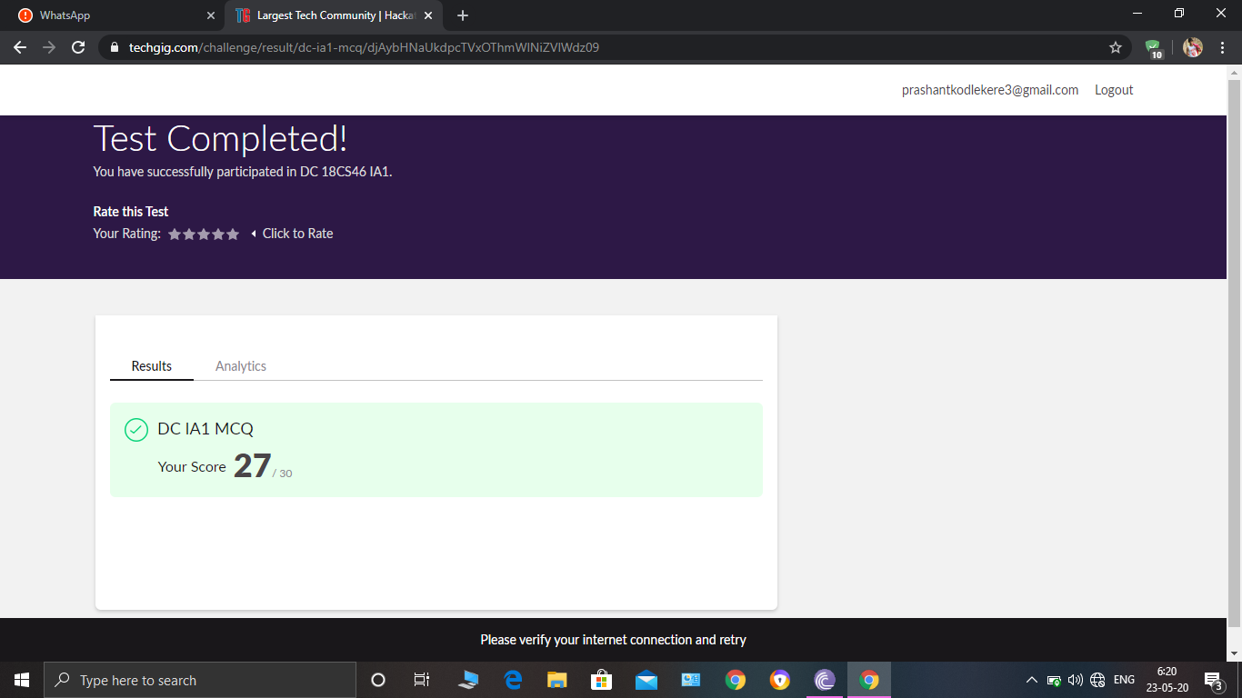

DATA COMMUNICATION Internals was conducted. A total of 30 questionS were Multiple Choice Questions.

The above snapshot is the result sheet which was mailed to us by the Techgig team.

Certification Course Details:

Course name:INTRODUCTION TO CYBER SECURITY(2ND AND 3RD SESSION)

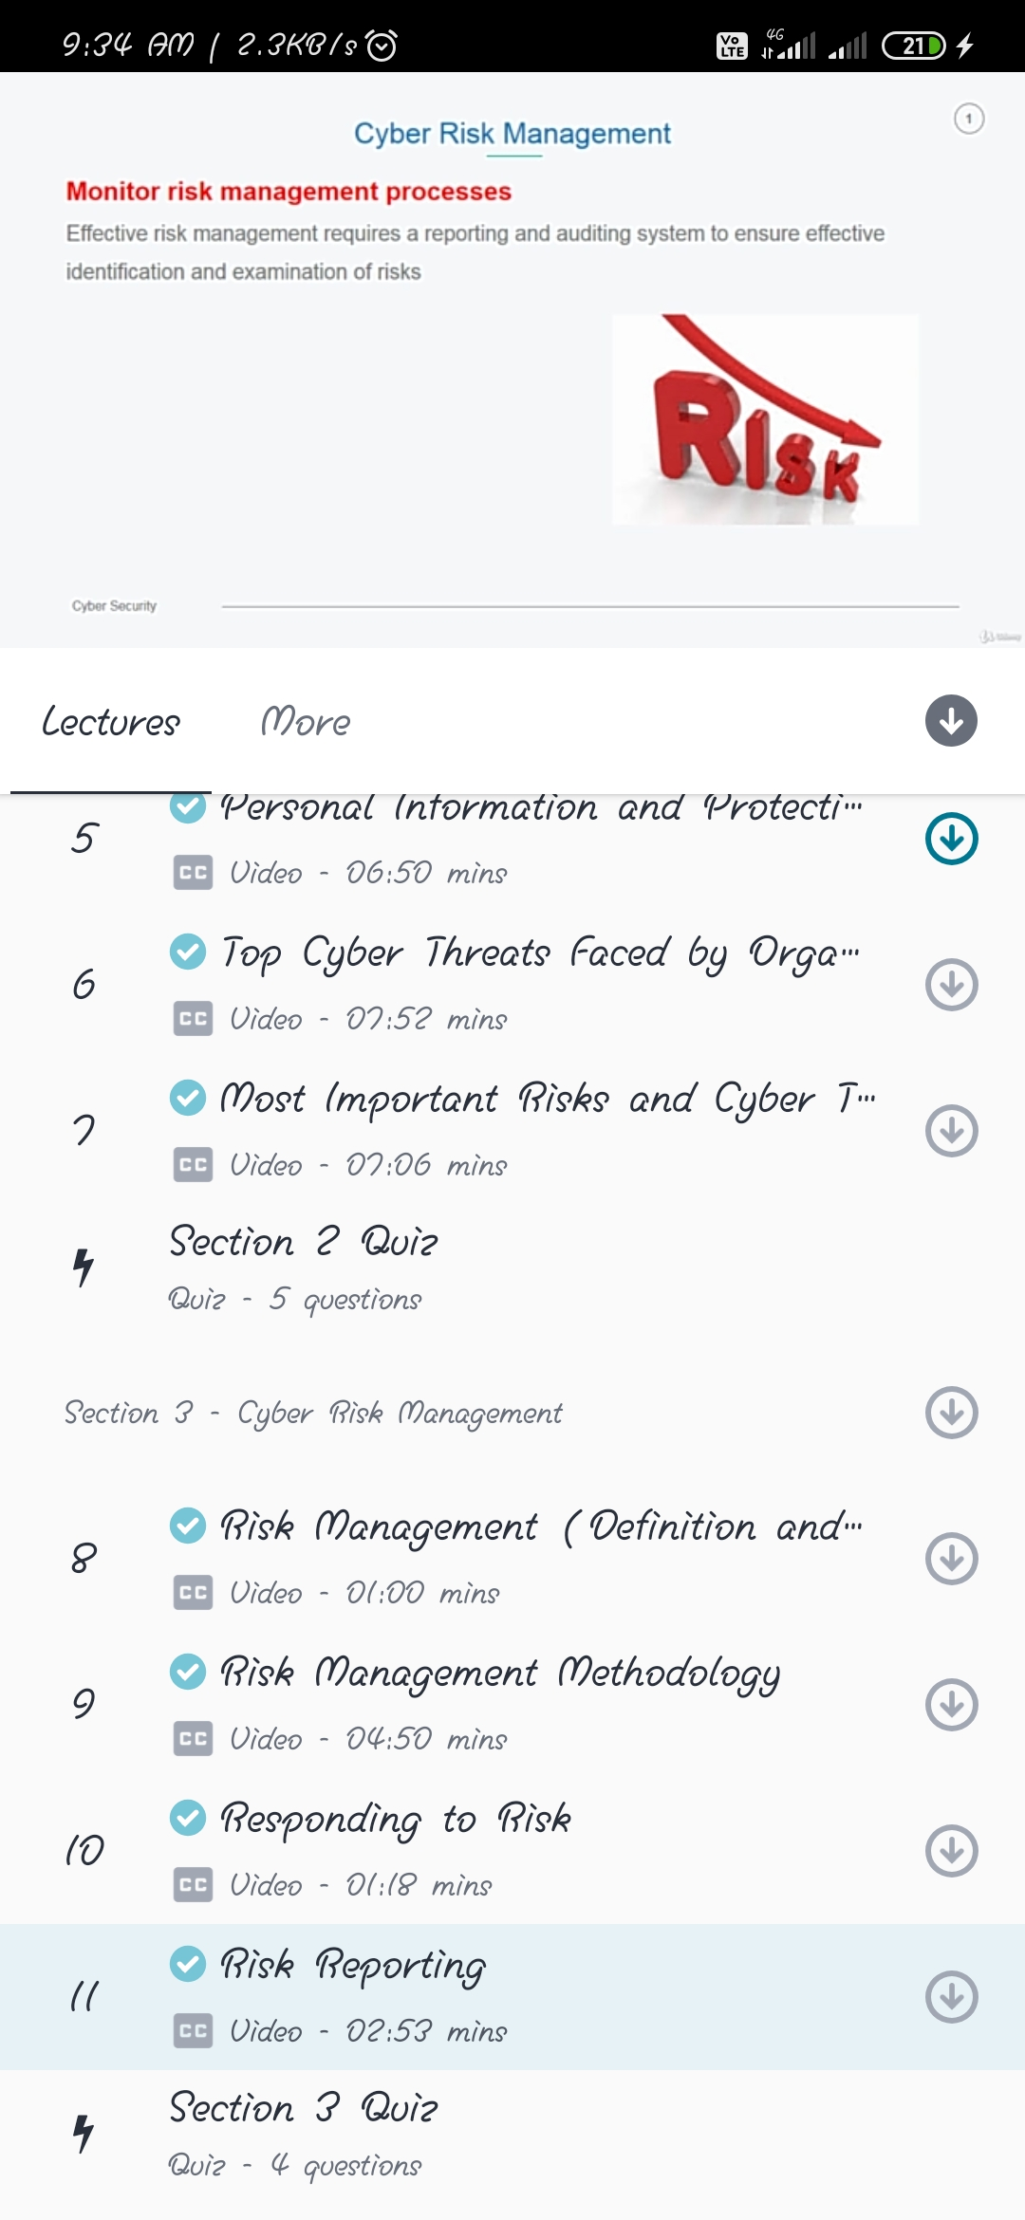

In second session I have learnt about personal information and protection and top cyber threats faced by organizations and also learnt about most important risks and cyber threats.

In session 3,I have learnt some basics of risk management and its methodology and also about risk reporting.

Coding Challenges Details:

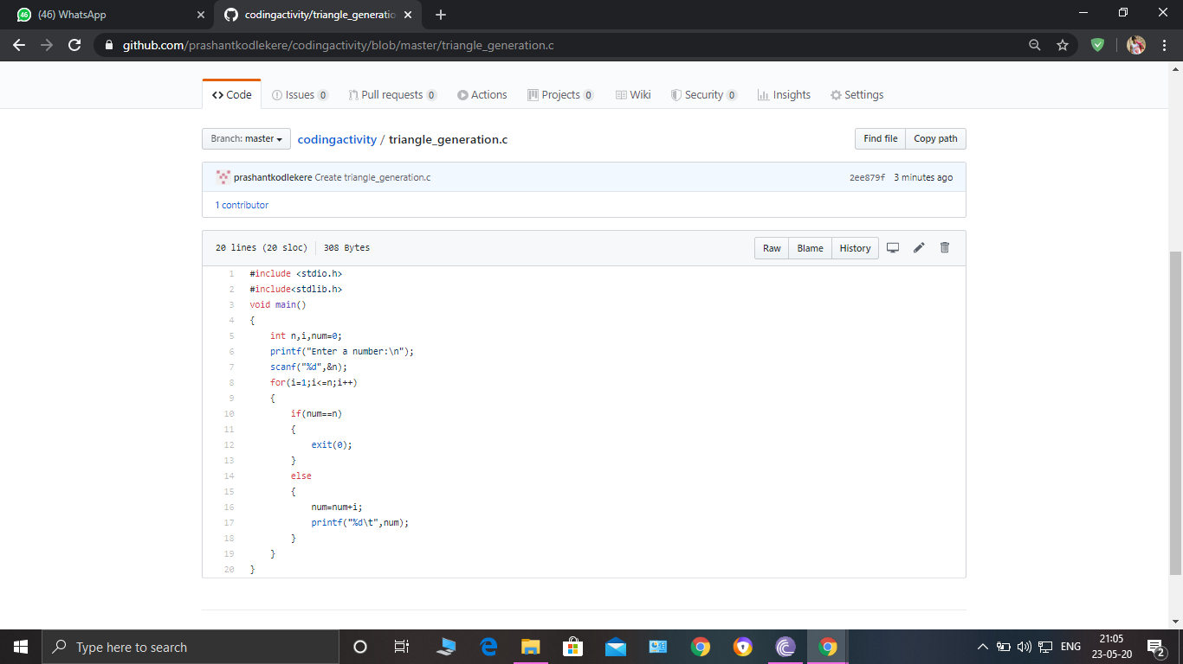

**The question I took to code is:**

[Write a C Program to generate first N Triangular Numbers (Where N is Read from the Key board).](https://github.com/orgs/alvas-education-foundation/teams/2nd-year/discussions/78)

Code: The above snapshot is the code which I have uploaded in my Github repository.